# Mathematical Methods in Engineering and Applied Science Problem Set 8.

1. lot the phase portrait and classify the fixed points for the following systems:

$\dot{x} = -3x + 2y, \dot{y} = x -2y;$

$$u={\left[x,y\right]}^{T};A=\left[\begin{matrix}-3 & 2 \\ 1 & -2\end{matrix}\right];$$

$$\frac{du}{dt}=Au$$

|  |  |  |  |
| --- | --- | --- | --- |
| Fixed point | $$v_{1},v_{2}$$ | $$λ_{1},λ_{2}$$ | Type |
| (0,0) | [1,1],[-2,1] | $$-1,-4$$ | Stable node |

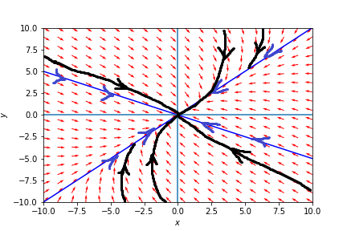



$\dot{x} = 5x + 10y, \dot{y} = -x -y$

$$A=\left[\begin{matrix}5 & 10 \\ -1 & -1\end{matrix}\right]$$

|  |  |  |  |
| --- | --- | --- | --- |
| Fixed point | $$v_{1},v_{2}$$ | $$λ_{1},λ_{2}$$ | Type |
| (0,0) | [-3+i,1],[-3-i,1] | $$2-i, 2+i$$ | Unstable spiral |

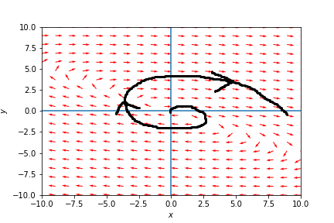

$\dot{x} = y, \dot{y} = -x -2y$

$$A=\left[\begin{matrix}0 & 1 \\ -1 & -2\end{matrix}\right]$$

|  |  |  |  |
| --- | --- | --- | --- |
| Fixed point | $$v_{1},v_{2}$$ | $$λ_{1},λ_{2}$$ | Type |
| (0,0) | [-1,1],[-1,1] | $$-1, -1$$ | stable node. |

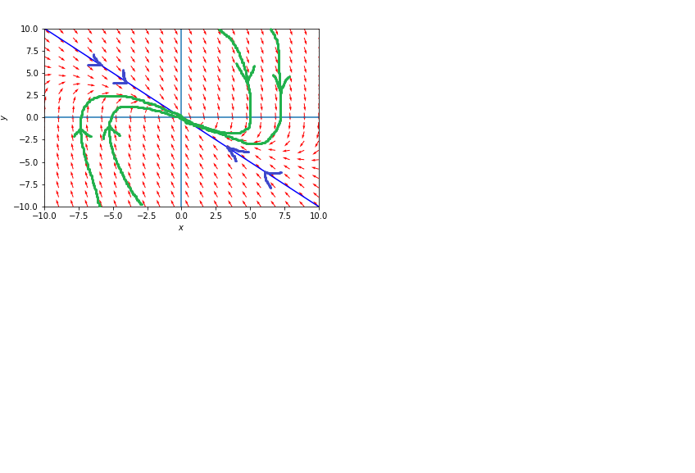

1. Suppose the relationship between Romeo and Juliet is such that

$$\dot{R} = aR + bJ, \dot{J} = -bR -aJ$$

with positive a and b. Describe the type of the relationship and explain its fate depending

on the initial conditions.

Romeo attitude towards to Juliet changes in the form of sum his attitude to J. ($aR$) and her attitude to him ($bJ)$. The more R positive towards J and the more J positive towards R the more R will be positive towards J in the next moment of time.

J is opposite. The more R positive towards J and the more J positive towards R the more J will be negative towards R in the next moment of time.

Let’s consider $A=\left[\begin{matrix}a & b \\ -b & -a\end{matrix}\right]$ the Fixed point is $[R,J] =[0,0]$.

|  |  |  |  |
| --- | --- | --- | --- |
| Fixed point | $$v_{1},v_{2}$$ | $$λ_{1},λ_{2}$$ | type |
| (0,0) | $$\left[-\frac{a}{b} +\frac{\sqrt{a^{2}-b^{2}}}{b},1\right],$$ $$\left[-\frac{a}{b}-\frac{\sqrt{a^{2}-b^{2}}}{b},1\right],$$ | $-\sqrt{a^{2}-b^{2}}$; $\sqrt{a^{2}-b^{2}}$; | Saddle node |

For $a>b$ e-vectors are real, and we have such phase portrait: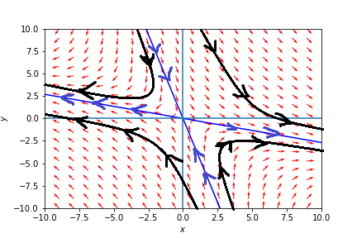

We can predict that in the future R will be infinitely + and J infinitely – or vice versa R will be infinitely - and J infinitely +.

For $a<b$ e-vectors becomes complex, and we have such phase portrait:

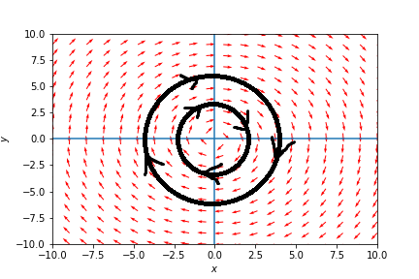

They always will change attitudes towards each other but $R^{2}+J^{2}=const\left(t\right)$

1. For the system

$$\dot{x} = xy -1, \dot{y} = x -y^{3},$$

find the fixed points, classify them, sketch the neighboring trajectories and try to fill in

the rest of the phase plane.

Fixed points:

$$x=\frac{1}{y}=>\frac{1}{y}-y^{3}=0=>y^{4}=1$$

$$y^{4}=e^{2πn}=>y=e^{\frac{2πn}{4}}=e^{\frac{πn}{2}}=1,-1,i,-i$$ Fixed points:

|  |  |  |  |  |
| --- | --- | --- | --- | --- |
|  |  |  |  |  |
|  |  |  |  |  |

|  |  |  |  |
| --- | --- | --- | --- |
| Fixed point | v1, v2 | $$λ_{1},λ_{2}$$ | Type |
| $$(1,1)$$ | $$\left[2+\sqrt{5},1\right] \\ \left[2-\sqrt{5},1\right]$$ | $$-1+\sqrt{5} \\ -1-\sqrt{5}$$ | Saddle point |
| $$(-1,-1)$$ | $$\left[1,1\right] \\ [1,1]$$ | $$-2 \\ -2$$ | Stable node |
| $$(-i,i)$$ | … |  |  |

I don’t know how to represent imaginary fixed points, though there are only real.

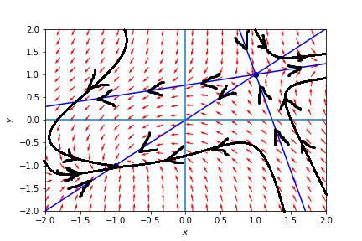

1. For the following model of rabbits and sheep, find the fixed points, investigate their

stability and draw the phase portrait. Indicate the basins of attraction of any stable

fixed point:

$$\dot{x} = x (3 -2x -2y) , \dot{y} = y (2 -x -y) .$$

$$x \left(3 -2x -2y\right)=0$$

$$y \left(2 -x -y\right)=0$$

Fixed points

|  |  |  |  |
| --- | --- | --- | --- |
|  |  |  |  |
|  |  |  |  |

|  |  |  |  |
| --- | --- | --- | --- |
| Fixed point | v1, v2 | $$λ_{1},λ_{2}$$ | Type |
| $$(0,0)$$ | $$\left[0,1\right] \\ \left[1,0\right]$$ | $$2 \\ 3$$ | Unstable node |
| $$(0,2)$$ | $$\left[0,1\right] \\ \left[-\frac{1}{2},1\right]$$ | $$-2 \\ -1$$ | stable node |
| $$\left(\frac{3}{2},0\right)$$ | $$\left[1,0\right] \\ \left[-\frac{6}{7},1\right]$$ | $$-3 \\ \frac{1}{2}$$ | Saddle point |

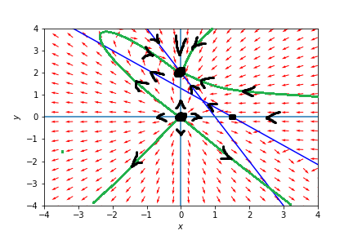

1. Consider the system

$$\dot{x} = -y -x^{3}, \dot{y} = x$$

Show that the origin is a spiral, although the linearization predicts a center.

$$J = \left[\begin{matrix}-3x^{2} & -1 \\ 1 & 0\end{matrix}\right]$$

|  |  |  |  |
| --- | --- | --- | --- |
| Fixed point | v1, v2 | $$λ_{1},λ_{2}$$ | Type |
| $$(0,0)$$ | $$\left[-I,1\right] \\ \left[I,1\right]$$ | $$-I \\ I$$ | Center |

$$λ_{1},=λ_{2}^{*}, Re\left(λ_{1}\right)=0-center$$

If we change coordinates to:

$$x=r cos\left(ϕ\right), y=r\sin\left(ϕ\right),$$

Consider derivative of $r^{2}=x^{2}+y^{2}:$

$$2r\dot{r}=2x\dot{x}+2y\dot{y}=2x\left(-y -x^{3}\right)+2yx=-y 2x-x^{3}2x+2yx=-x^{3}2x$$

$$\dot{r}=-\frac{x^{4}}{r}=-\frac{r^{4}\cos\left(ϕ\right)}{r}=-r^{3}\cos\left(ϕ\right)$$

Radius is always decreasing. It is spiral.

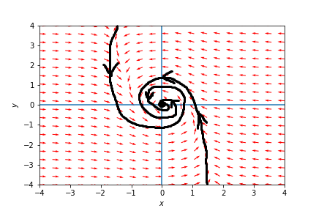

1. he Kermack-McKendrick model of an epidemic describes the population of healthy

people x (t) and sick people y (t) in terms of the equations

$$\dot{x} = -kxy$$

$$\dot{y}= kxy -ly,$$

where k, l > 0. Here, l is the death rate of the sick people, and kxy in equation for

̇y implies that people get sick at a rate proportional to their encounters (which itself

is proportional to the product of the number of sick people y and healthy people x).

The parameter k measures the probability of transmission of the disease during the encounters.

1. Find and classify the fixed points.

Fixed points: $(y=0,x∈R)$

1. Sketch the nullclines and the vector field.

$$J = \left[\begin{matrix}-ky & -kx \\ ky & kx-l\end{matrix}\right]$$

$$J = \left[\begin{matrix}- kx+l & -kx \\ 0 & 0\end{matrix}\right] v=0$$

$$\left[\begin{matrix}- kx+l & -kx \\ 0 & 0\end{matrix}\right] v=\left(- kx+l\right)v1- kxv2=0$$

|  |  |  |  |
| --- | --- | --- | --- |
| Fixed point | v1, v2 | $$λ_{1},λ_{2}$$ | Type |
| $$(x,0)$$ | $$\left[1,0\right] \\ \left[-\frac{kx}{kx-l},1\right]$$ | $$0 \\ kx-l$$ | Saddle-nodes borderline |

|  |  |  |
| --- | --- | --- |
| X: | v2 | $$λ_{2}$$ |
| $$-∞<x<0$$ | $$\left[-\frac{kx}{kx-l}<0,1\right]$$ | $$kx-l<0$$ |
| $$x=0$$ | $$\left[0,1\right]$$ | $$kx-l<0$$ |
| $$0<x<\frac{l}{k}$$ | $$\left[-\frac{kx}{kx-l}>0,1\right]$$ | $$kx-l<0$$ |
| $$\frac{l}{k}<x<∞$$ | $$\left[-\frac{kx}{kx-l}<0, 1\right]$$ | $$kx-l>0$$ |

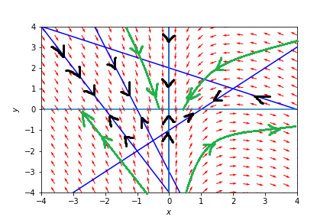

1. Find a conserved quantity for the system (hint: form an ODE for dy/dx and integrate it).
$$\frac{dx}{dt} = -kxy, \frac{dy}{dt}= kxy -ly$$

$$\frac{dy}{dt}\frac{dt}{dx}= \frac{dy}{dx}=\frac{kxy -ly}{-kxy}=\frac{-kx+l}{kx}=-1+\frac{l}{kx}$$

$$\int{dy}=\int{\left(-1+\frac{l}{kx}\right)dx}=-x+\frac{l}{k}\ln\left(x\right)+C=y$$

$$y+x-\frac{l}{k}\ln\left(x\right)=C$$

2. Plot the phase portrait. What happens as t →∞?

We consider case when x > 0, y>0, because it is count of people.

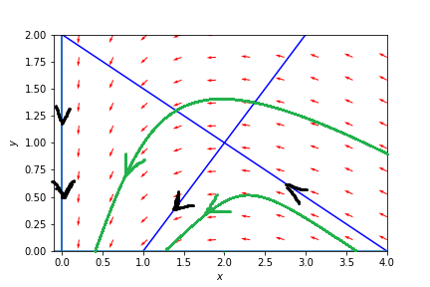

Blue: nullclines

Green: trajectories.

l/k = 2

At the $t→∞$ $,y→0$, $x-\frac{l}{k}\ln\left(x\right)→C$

From initial conditions we have total number of people $S = x_{0} +y_{0}$ => $$y+x-\frac{l}{k}\ln\left(x\right)=S-x_{0}+x_{0}-\frac{l}{k}\ln\left(x_{0}\right)=S-\frac{l}{k}\ln\left(x_{0}\right)=C$$

Where S – total number of people initially, $x_{0}$ are healthy people.

$$x-\frac{l}{k}\ln\left(x\right)→S-\frac{l}{k}\ln\left(x_{0}\right)$$

1. Let (x0, y0) be the initial condition. Under what conditions on (x0, y0) will the

epidemic occur? (Epidemic occurs if y (t) increases initially).

From the table (b) it is clear that $v_{2}$ lay along the x axis when $x =\frac{l}{k}$, if $x<\frac{l}{k}, dy$ is negative, if $x>\frac{l}{k}$, dy is positive and epidemic occurs.

It is also clear if consider: $\dot{y}= kxy -ly=(kx -l)y$, where y > 0.

So $x_{0}>\frac{l}{k}, y_{0}>0$